Court Data Standard Dictionary

2022-06-03 Version 1

# Introduction and Purpose

As more individuals turn to online search engines for information, the need for mature tools to assist in finding the location of the correct court for a legal matter has grown. The Pew Charitable Trusts' civil legal modernization project is partnering with court administrators and their information technology specialists to create a court data standard that will support the transfer of information between courts and information providers such as Google, Apple, and Microsoft so that individuals can find information on the court they need.

## Methodology

Data points common to courthouses in a number of diverse court systems were reviewed with an eye toward those that would be both most useful to the public as well as easily maintainable by court administrators in the event of changes. This data was mapped to existing properties of [Schema.org](https://schema.org), a web metadata standardization project founded by Google, so that the information made available through this project will be consumable by existing search engines and tools.

While effort has been made to include court administrators and other professionals in the legal system space in the development of this data standard, the identified terms may not at this time be representative of all that may be included in the final format, nor may they all be applicable to every court system. If you would like to provide feedback or suggestions on the data standard as it is being developed, please contact [courtdata@turnout.rocks](mailto:courtdata@turnout.rocks).

**Pilot Process and Data Standard Implementation**

The data standard developers will gather the information necessary to build files containing the courthouse data on which the central state-level datastores will be based. Court administrators will be asked to identify local courts to participate in the pilot who will be willing to host the data files on their websites. The developers will build tools capable of automating the collection of data from court websites and validating it against the requirements of the Court Data Standard. Courthouse information will be aggregated and returned to each state's court administrators for review and as an example of the anticipated final product.

A separate document will be forthcoming that details the steps necessary to build the data files so that court administrators at the state or local level can generate them independently as part of wider adoption of the standard should they so choose.

# Data Format

JSON-LD (JavaScript Object Notation – Linked Data) is the preferred encoding for Google Rich Text and can be used by the search engine to automatically generate the information boxes that appear to the right of search results pages when enough information about a subject is available. It is also compatible with Schema.org, on which much of the standard is based.

Examples are provided throughout the document using JSON-LD syntax. More information on the JSON-LD format is available at <https://json-ld.org/>.

**The Court Data Standard**

The following section serves as a dictionary for the terms currently included in the court data standard. Types, properties, data types, expected values, definitions, and examples are included and should serve as a reference during the construction of the files used to store court related information.

**Data Types**

The Court Data Standard requires values to be of a specific predefined type for each property. This facilitates standardization, consistency, and ease of automated collection of court data. An explanation of data types follows below.

**Text**

Text (also known as a string) is a sequence of characters. Be sure to read the description for each text property, as some properties only allow values that are formatted in a specific manner. Text values must be free of leading or trailing whitespace.

**URL**

A Uniform Resource Locator (URL) is a unique sequence of characters that identifies the location of resources on the web, most commonly websites. <https://www.google.com> is an example of a URL.

**DateTime**

A DateTime is an expression of a date and/or time in an [ISO-8601](https://en.wikipedia.org/wiki/ISO_8601) compliant format. For the purposes of this standard, only the time portion of a DateTime value is required. Time must be expressed in four-digit 24-hour format with hours and minutes separated by a colon (:). The time zone must also be indicated by appending a plus or minus symbol (+, -) and the GMT offset immediately after the minutes (e.g., 9:00 AM PST would be expressed as 09:00-08:00).

## Structured Types

In the context of the vocabulary of Schema.org, a structured type refers to the overall category of entity or thing being described. In programming, this would be similar to a class. The Court Data Standard is composed of a combination of existing types as well as some that have been created to accommodate data related to courts.

Each property listed in the section following this one is used by one or more types to describe its subject. Properties may be shared between different types (e.g., a courthouse, a person, and a court system may all have a “name”). The section below describes the types included in the Court Data Standard as well as the properties associated with them.

Properties and types can be textually distinguished by their casing: properties are recorded with camelCase while types are recorded with PascalCase.

### AdministrativeArea

**Description:** A geographical region, typically under the jurisdiction of a particular government organization.

**Associated Properties:**

* name
* geoContains
* containsPlace
* areaServed

### ContactPoint

**Description:** A person or resource which can be reached by members of the public for information about the courthouse or the services it offers.

**Associated Properties:**

* contactType
* description
* email
* telephone

### Courthouse

**Description:** A public building in which legal matters are conducted, especially those involving courts and judges or other officials.

**Associated Properties:**

* areaServed
* contactPoint
* hasOfferCatalog
* image
* knowsLanguage
* location
* name
* url

### CourtSystem

**Description:** A statewide organization of courts and courthouses.

**Associated Properties:**

* name
* areaServed

### OfferCatalog

**Description:** A collection of lists of items that contains information about amenities.

**Associated Properties:**

* itemListElement

### OpeningHoursSpecification

**Description:** The hours and days of the week during which the courthouse is open to the public.

**Associated Properties:**

* dayOfWeekdayOfWeek
* closes
* opens

### Place

**Description:** Entities that have a somewhat fixed, physical extension.

**Associated Properties:**

* address
* openingHoursSpecification
* hasMap

### PostalAddress

**Description:** The physical address at which the courthouse is located.

**Associated Properties:**

* addressLocality
* addressRegion
* postalCode
* streetAddress

**Properties and Definitions**

### The following properties are listed in the order in which they appear in the JSON-LD example at the end of this document.

### name

**Property Name**: name  
**Expected Value/Type**: Text  
**Description**: The official name of the entity being described. This may be associated with an administrative area, person, system, or a courthouse itself.  
**Example**:

"name": "State of Illinois Circuit Court System”

"name": "Cook County: Fifth Municipal District - Bridgeview Courthouse"

### area served

**Property Name**: areaServed  
**Expected Value/Type**: AdministrativeArea  
**Description**: Represents the geographic area served by a Courthouse or a CourtSystem. When used by a CourtSystem, the areaServed may point to one or more AdministrativeAreas to represent geographic divisions of the court, e.g., districts and circuits.

### composing administrative area

**Property Name**: geoContains  
**Expected Value/Type**: AdministrativeArea  
**Description**: The AdministrativeArea(s) contained in the AdministrativeArea being described.

### local court

**Property Name**: containsPlace  
**Expected Value/Type**: Courthouse  
**Description**: The courthouse(s) in the AdministrativeArea. This property is only expected for the highest granularity administrative areas, i.e., the administrative areas that have no geoContains property.

### address

**Property Name**: address  
**Expected Value/Type**: PostalAddress  
**Description**: The physical address of the courthouse made up of street address, city, state, and zip code.

### location

**Property Name**: location  
**Expected Value/Type**: Place   
**Description**: Information about the courthouse including physical address, operating hours, and a map.

### street address

**Property Name**: streetAddress  
**Expected Value/Type**: Text  
**Description**: The street address portion of the courthouse's physical address. Abbreviations must be expanded.  
**Example**:

"streetAddress": "123 Main Street"

### city

**Property Name**: addressLocality  
**Expected Value/Type**: Text  
**Description**: The city portion of the courthouse's physical address.  
**Example**:

"addressLocality": "Albuquerque"

### state

**Property Name**: addressRegion  
**Expected Value/Type**: Text  
**Description**: The state portion of the courthouse's physical address. This must be a two-character state abbreviation.  
**Example**:

"addressRegion": "NM"

### zip code

**Property Name**: postalCode  
**Expected Value/Type**: Text  
**Description**: The zip code portion of the courthouse's physical address. This must be a five-digit number.  
**Example**:

"postalCode": "62301"

### business hours

**Property Name**: openingHoursSpecification  
**Expected Value/Type**: OpeningHoursSpecification  
**Description**: The days and times at which the courthouse is open to the public.

### open time

**Property Name**: opens  
**Expected Value/Type**: DateTime.  
**Description**: The time at which the courthouse opens to the public.

**Example**:

"opens": "09:00-08:00"

### close time

**Property Name**: closes  
**Expected Value/Type**: Datetime  
**Description**: The time at which the courthouse closes to the public.

**Example**:

"closes": "16:30-08:00"

### open days

**Property Name**: dayOfWeek  
**Expected Value/Type**: Text  
**Description**: A text list of the days of the week during which the courthouse is open to the public. These must be spelled out in full and not abbreviated. Days must be separated by a comma and whitespace.

**Example**:

"dayOfWeek": "Monday, Tuesday, Wednesday, Thursday, Friday"

### map URL

**Property Name**: hasMap  
**Expected Value/Type**: URL  
**Description**: A URL to a webpage containing a map that indicates the courthouse's physical location.  
**Example**:

"hasMap": "https://www.cookcountycourt.org/ABOUT-THE-COURT/Municipal-Department/Fifth-Municipal-District-Bridgeview"

### courthouse image

**Property Name**: image  
**Expected Value/Type**: URL  
**Description**: A URL linking directly to an image of the courthouse.  
**Example**:

"image": "https://www.cookcountycourt.org/ABOUT-THE-COURT/Municipal-Department/Fifth-Municipal-District-Bridgeview"

### contact point

**Property Name**: contactPoint  
**Expected Value/Type**: ContactPoint   
**Description**: A telephone number and/or email address at which courthouse staff or resources may be reached by members of the public.

### contact type

**Property Name**: contactType  
**Expected Value/Type**: Text  
**Description**: The title or function of the service, department, or person with whom the contact information is associated.  
**Example**:

"contactType": "General Court Information"

"contactType": "Court Accessibility Coordinator"

"contactType": "Jury Service"

### contact name

**Property Name**: description

**Expected Value/Type**: Text  
**Description**: The name and title of the person with whom the contact information is associated. If the number or email address leads to an automated message or a line that no one person is responsible for answering the value “NA” must be entered.  
**Example**:

"description": "John Smith, Circuit Clerk"

"description": "NA"

### contact telephone

**Property Name**: telephone  
**Expected Value/Type**: Text  
**Description**: The phone number at which a person, service, or department associated with the courthouse may be reached. It must be expressed in ten-digit format with the area code enclosed in parentheses, a whitespace between the area code and first group of digits, and a dash between the second and third group of digits.  
**Example**:

"telephone": "(679) 574-6314"

### contact email

**Property Name**: email  
**Expected Value/Type**: Text  
**Description**: The email address at which a person, service or department associated with the courthouse may be reached.

**Example**:

"email": "guy.smiley@courts.ca.gov"

### court webpage

**Property Name**: url  
**Expected Value/Type**: URL  
**Description**: A URL to the webpage of the courthouse.  
**Example**:

"url": "https://www.cookcountycourt.org/ABOUT-THE-COURT/Municipal-Department/Fifth-Municipal-District-Bridgeview"

### has amenities

**Property Name**: hasOfferCatalog  
**Expected Value/Type**: OfferCatalog  
**Description**: An indicator that a courthouse offers amenities to the public, such as free wifi, restrooms, etc.

### amenities offered

**Property Name**: itemListElement  
**Expected Value/Type**: Text  
**Description**: A list of amenities offered to the public at the courthouse. Each amenity should be separated by a comma and whitespace.  
**Example**:

"itemListElement: "e-filing kiosk, internet", public restrooms, waiting area"

### languages spoken

**Property Name**: knowsLanguage  
**Expected Value/Type:** Text  
**Description:** The language orAlanguages spoken or that may be accommodated at the courthouse. Languages must be expressed with [ISO 639-1 compliant](https://en.wikipedia.org/wiki/List_of_ISO_639-1_codes) two-character codes. If multiple languages are accommodated, they should be recorded as a list with a comma and whitespace separating languages.  
**Example**:

"knowsLanguage": "en, es"

**Representing Court Structures**

The **CourtSystem** is a *structured type* within the Court Data Standard. Each **CourtSystem** has an **areaServed**. This property links the organization with its **AdministrativeArea** (a geographic structure). Each **AdministrativeArea** can be broken down into further, constituent **AdministrativeAreas** using the **geoContains** property. When there are no more subdivisions, then each **CourtHouse** is listed using the **containsPlace** property.

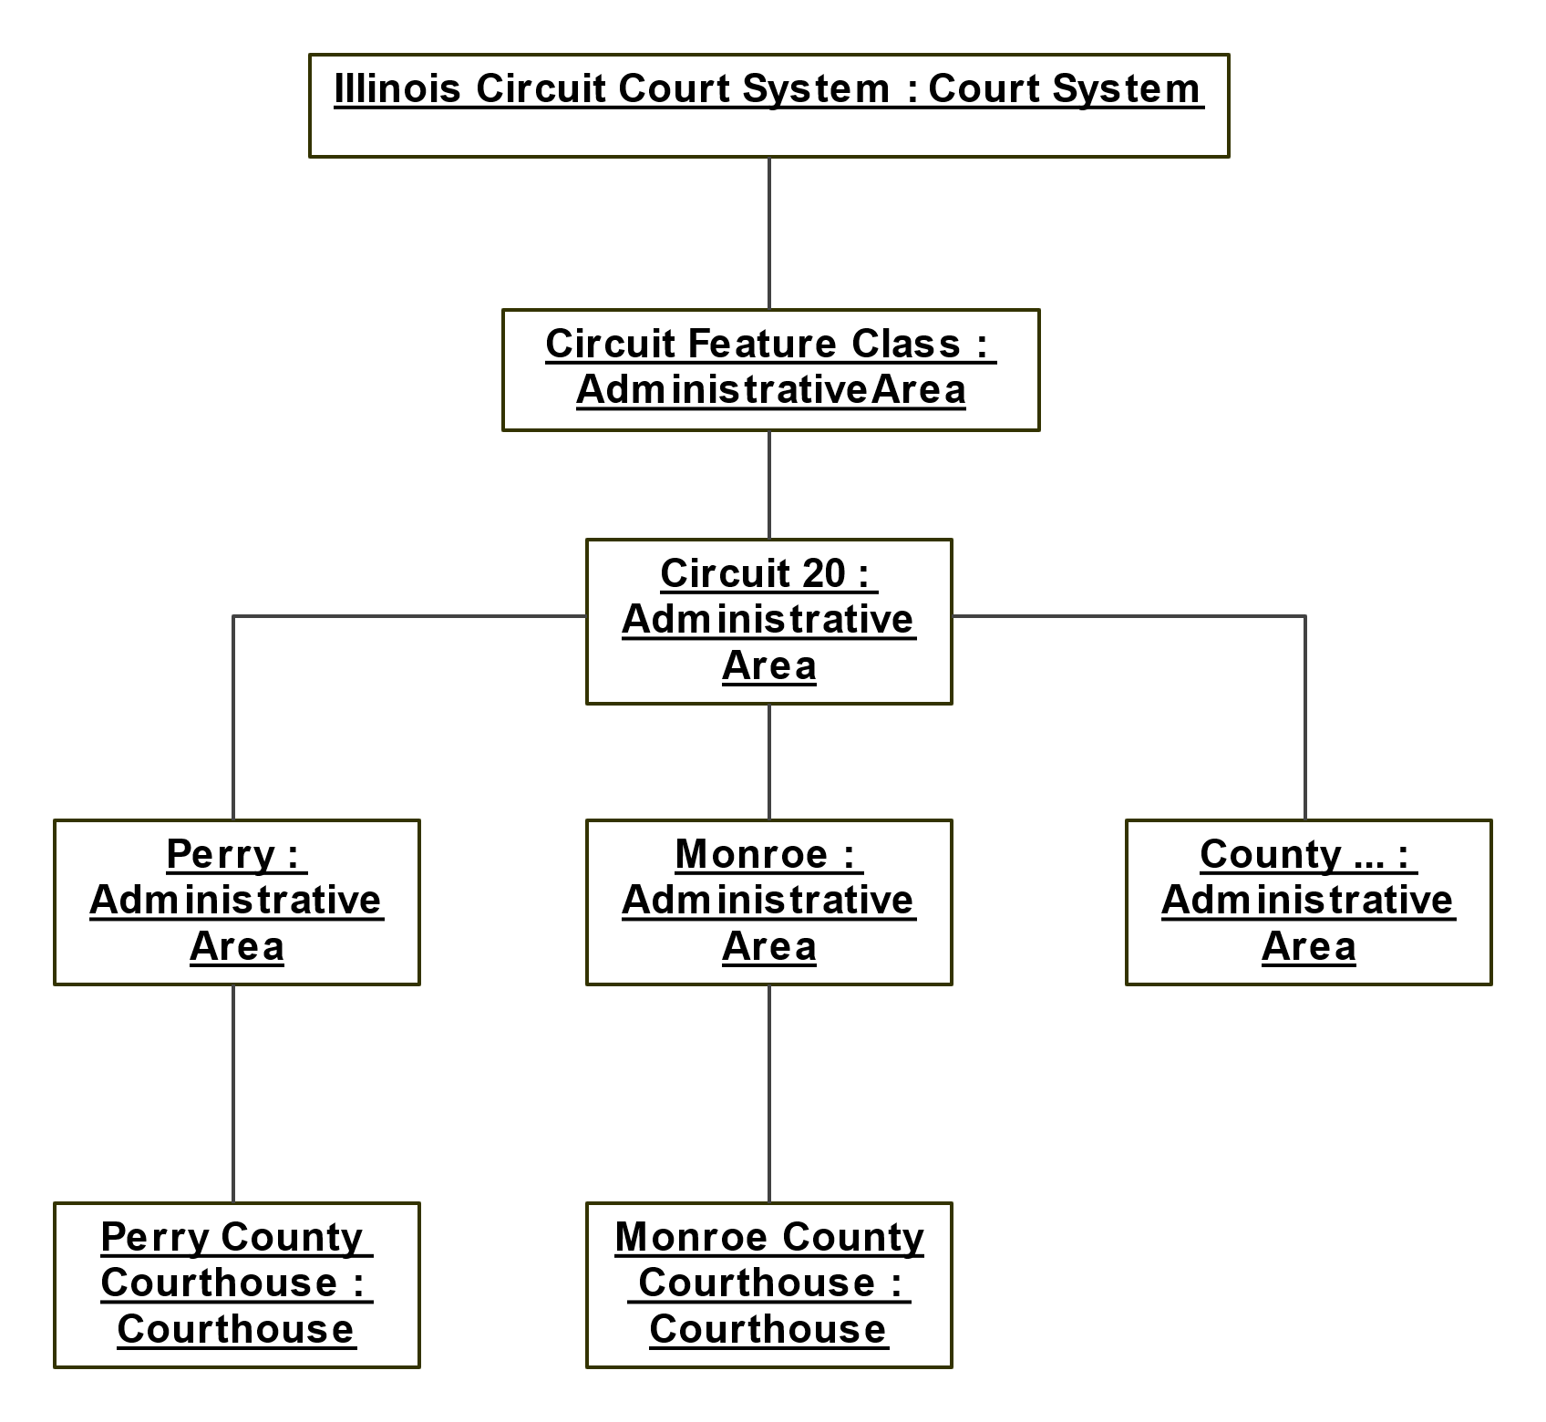

More nuances related to court districts are expected to be uncovered as the pilot proceeds, but this simplified structure will suffice for the initial phases.

## Example

The following example shows a court system containing a single district, that has a single circuit, which contains a single courthouse. This is highly simplified from what would be expected by an actual court system but should serve to illustrate how the format can be used.

[

{

"@context": "https://schema.org/",

"@type": [

"http://schema.org/Organization",

"http://pew.org/Court/CourtSystem"

],

"@id": "https://www.illinoiscourts.gov/OrgCircuit",

"name": "State of Illinois Circuit Court System",

"areaServed": {

"@id": "https://www.illinoiscourts.gov/Circuit"

}

},

{

"@context": "https://schema.org/",

"@id": "https://www.illinoiscourts.gov/Circuit",

"@type": "https://schema.org/AdministrativeArea",

"name": "State of Illinois Circuit Feature Class",

"geoContains": [

{

"@id": "https://www.illinoiscourts.gov/Circuit/1"

}

]

},

{

"@context": "https://schema.org/",

"@id": "https://www.illinoiscourts.gov/Circuit/1",

"@type": "https://schema.org/AdministrativeArea",

"name": "State of Illinois Circuit Court - District 1",

"geoContains": [

{

"@id": "https://www.illinoiscourts.gov/Circuit/1/Cook"

}

]

},

{

"@context": "https://schema.org/",

"@id": "https://www.illinoiscourts.gov/Circuit/1/Cook",

"@type": "https://schema.org/AdministrativeArea",

"containsPlace": [

{

"@id": "https://www.cookcountycourt.org/"

}

],

"name": "State of Illinois Circuit Court - District 1 - Cook County Circuit"

},

{

"@context": "https://schema.org/",

"@id": "https://www.cookcountycourt.org/",

"@type": [

"http://schema.org/LocalBusiness",

"http://schema.org/GovernmentBuilding",

"http://pew.org/Court/Courthouse"

],

"name": "Bridgeview Courthouse",

"areaServed": {

"@id": "https://www.illinoiscourts.gov/Circuit/1/Cook"

},

"location": {

"@type": "https://schema.org/Place"

"address": {

"@type": "https://schema.org/PostalAddress",

"streetAddress": "521 Vermont Street",

"addressLocality": "Quincy",

"addressRegion": "IL",

"postalCode": "62301"

},

"openingHoursSpecification": {

"@type": "https://schema.org/OpeningHoursSpecification",

"opens": "09:00-06:00",

"closes": "16:30-06:00",

"dayOfWeek": [

"Monday",

"Tuesday",

"Wednesday",

"Thursday",

"Friday"

]

},

"hasMap": "https://www.cookcountycourt.org/ABOUT-THE-COURT/Municipal- Department/Fifth-Municipal-District-Bridgeview"

},

"image": "https://www.cookcountycourt.org/ABOUT-THE-COURT/Municipal-Department/Fifth-Municipal-District-Bridgeview",

"contactPoint": [

{

"@type": "https://schema.org/ContactPoint",

"contactType": "General Court Information",

"description": "Randy Pollard, Circuit Clerk",

"telephone": "(217) 277-2100",

"email": "rpjeffcocircuitclerk@il.us"

},

{

"@type": "https://schema.org/ContactPoint",

"contactType": "Court Accessibility Coordinator",

"description": "Michael Smith, Deputy Administrator of Court Operations",

"telephone": "(815) 544-0371",

"email": "rwagner@co.adams.il.us"

}

],

"url": "https://www.cookcountycourt.org/ABOUT-THE-COURT/Municipal-Department/Fifth-Municipal-District-Bridgeview",

"hasOfferCatalog": {

"@context": "https://schema.org/",

"@type": "http://schema.org/OfferCatalog",

"itemListElement": [

"copier",

"e-filing kiosk",

"food",

"free parking",

"internet",

"language access",

"law library",

"mobile devices allowed",

"printer",

"public transportation",

"self-help center",

"waiting room"

]

},

"knowsLanguage": "@en"

}

]